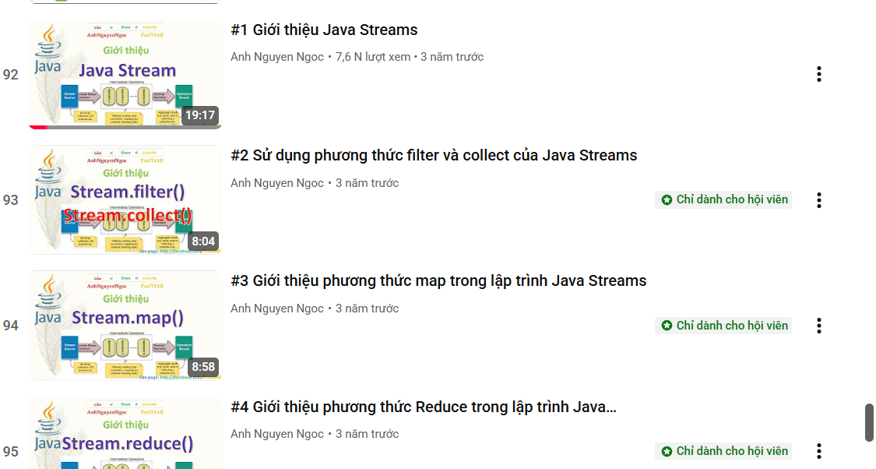
https://www.youtube.com/playlist?list=PLn9lhDYvf_3HZwLTxoWG4eDPFq2aVYTHC
ava-functional-programming
https://www.udemy.com/course/java-functional-programming/?couponCode=PMNVD2525
https://www.udemy.com/course/modern-java-learn-java-8-features-by-coding-it/?couponCode=PMNVD2525

